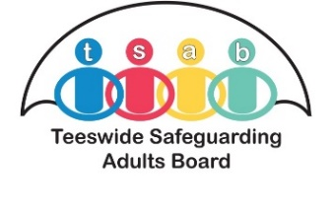
Campaign Monday 21- 25 September 26

A Spotlight on Identify & Report Safeguarding Concerns
Safeguarding Adults


Campaign Highlights
Throughout the week TSAB will be promoting:
✅ A new Decision Support Guidance (DSG) resource for professionals
✅ A safeguarding awareness animation
✅ Safeguarding workshops and webinars
✅ Awareness-raising posters and promotional resources
✅ Special safeguarding communications and social media messages throughout the week

Safeguarding concerns can involve:
- Physical abuse
- Psychological or emotional abuse
- Financial abuse
- Neglect and acts of omission
- Domestic abuse
- Sexual abuse
- Discriminatory abuse
- Organisational abuse
- Self-neglect
- Modern slavery and exploitation
If something doesn't feel right, seek advice or report your concerns.

Out For……...


Safeguarding is everyone's business.
Hartlepool Borough Council is supporting the Teeswide Safeguarding Adults Board (TSAB) campaign:
"A Spotlight on Identifying and Reporting Safeguarding Concerns" from 21-25 September 2026. The campaign aims to raise awareness of safeguarding, help people recognise when an adult may be at risk of abuse or neglect, and promote confidence in reporting concerns.
Why Is This Important?
Many adults may experience abuse, neglect or exploitation and rely on professionals, volunteers, carers, family members and members of the public to recognise the signs and take action.
Knowing what to look for and how to report a concern can make a significant difference to someone's safety, wellbeing and quality of life.
See Something? Say Something.
If you are concerned that an adult with care and support needs may be experiencing abuse or neglect, don't assume someone else will report it. Raising a concern could help protect someone from harm.

Key Campaign Messages
✔ Know the Signs
Be alert to indicators that an adult may be experiencing abuse, neglect or exploitation.
✔ Be Professionally Curious
Ask questions, explore concerns and consider whether there may be underlying risks affecting an individual's safety and wellbeing.
✔ Don't Ignore Concerns
Early identification and reporting can prevent harm and ensure people receive support at the earliest opportunity.
✔ See Something, Say Something
If you have a safeguarding concern, report it using the appropriate safeguarding procedures.



- Take Time to Refresh Your Knowledge
Review safeguarding procedures relevant to your role and ensure you know how to raise a concern.
- Attend a Workshop or Learning Event
✅Look out for information about TSAB safeguarding awareness workshops and webinars being promoted during the campaign week.
- Share Campaign Messages
✅ Read and share campaign communications with colleagues.
✅ Display campaign posters in offices, reception areas and community settings where appropriate.
✅ Refresh your knowledge of HBC and TSAB safeguarding procedures and reporting routes.
✅ Share TSAB social media messages to help raise awareness across our communities.
- Start Conversations
✅Use the campaign as an opportunity to discuss safeguarding within your team and reflect on how we can all support adults to stay safe.
- Promote a Culture of Professional Curiosity
Ask questions, be alerted to changing circumstances and act when concerns arise.

Policies, Procedures & Guidance

The Safeguarding Practice Manual provides information on all policies and procedures, and information is constantly added and updated for your reference.

The TSAB Website CAN BE ACCESSED VIA: www.tsab.org.uk and provides numerous links, updates and access to posters, leaflets and all policies and procedures.

What's Happening During the Week?
The campaign will include:
⭐ Launch of TSAB's new Decision Support Guidance (DSG) for professionals
⭐Release of a new safeguarding awareness animation
⭐Safeguarding workshops and webinars for professionals
⭐Campaign posters and awareness resources
⭐Social media activity and safeguarding messages throughout the week
⭐A special safeguarding newsletter and partner communications campaign
⭐Updates throughout the week



If in doubt, report it.
Safeguarding concerns can be raised by anyone. Every concern reported is an opportunity to help protect an adult from abuse, neglect or exploitation.
Together, we can help ensure that adults at risk receive the support, protection and dignity they deserve.



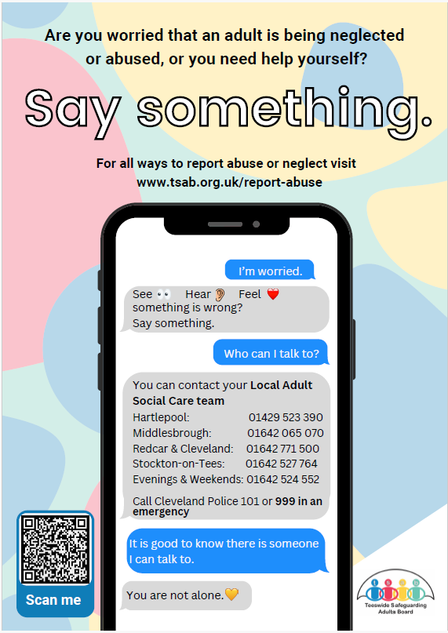
Campaign Poster

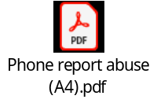
- What is Safeguarding webpage - What is Safeguarding? | Teeswide Safeguarding Adults Board
- What is Safeguarding Animation –
- What is Safeguarding? (BSL) - YouTube
- New animation launch – See Something, Say Something
- Safeguarding Videos
- Learning Briefings
- New guidance launch - Decision Support Guidance
- Report Abuse | Teeswide Safeguarding Adults Board
- Teeswide Inter-Agency Safeguarding Adults Policy | Teeswide Safeguarding Adults Board
- Inter-Agency Safeguarding Adults Procedure V12 FINAL - Accessible
- Think Family Guidance - Safeguarding Adults, Children and Families | Teeswide Safeguarding Adults Board
- Think-Family-Safeguarding-Adults-Children-and-Families-Checklist-V1.2-April-2022.pdf



